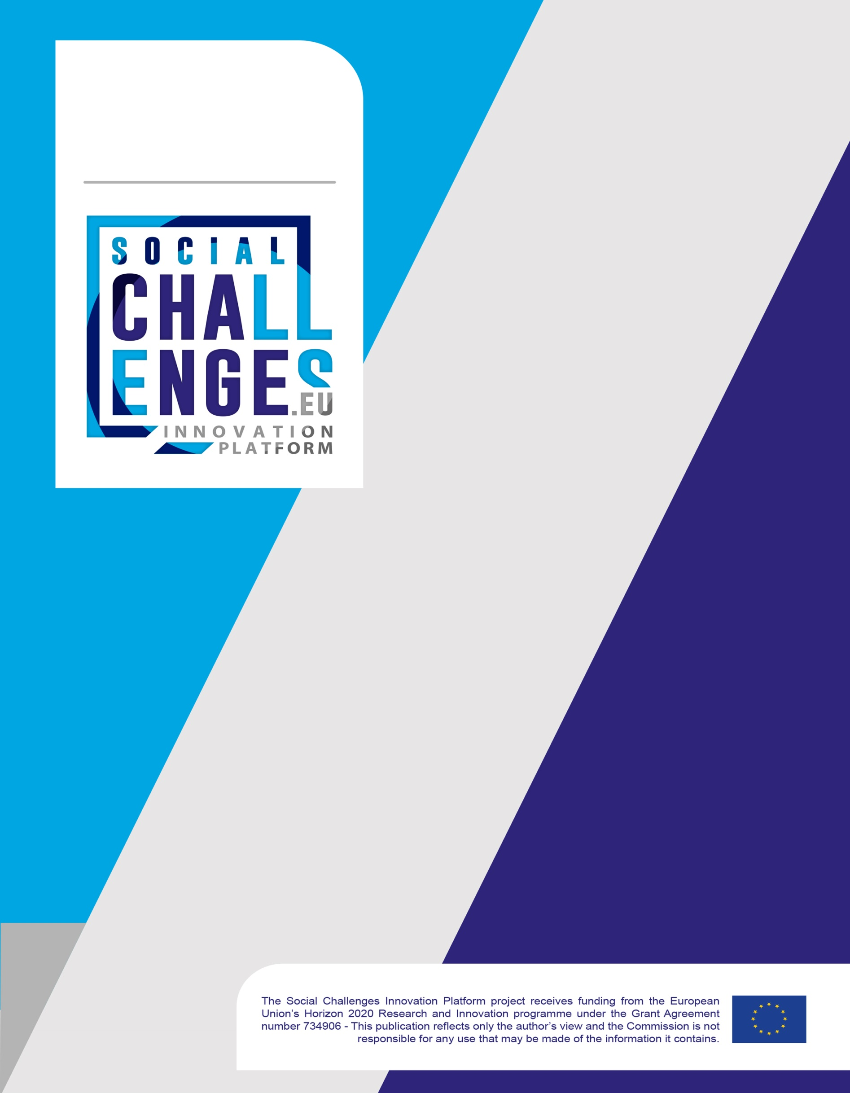
SocialChallenges.eu
Solution providers application form

SocialChallenges.eu - Solution providers application form

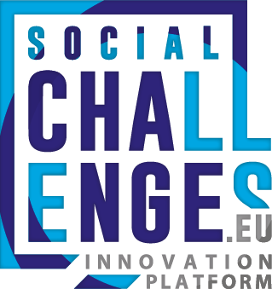

Social Challenges Innovation Platform project receives funding from the European Union’s Horizon 2020 research and innovation programme under the grant agreement n° 734906

IMPORTANT!
Submission Deadline: | 15st of April 2018 (23:59hrs CET)
To be Submitted on: | www.socialchallenges.eu
Instructions: | Complete the application (7 sections) and upload the file.  Please don’t forget to upload your pitching video too.
Applicant Guidance  and Helpdesk: | Read the Call Information document  For questions please contact SocialChallenges.eu helpdesk or email us at: solutionprovider@socialchallenges.eu

Proposal Summary
Project Name:
Project Acronym:
Applicant Name (organization):
Applicant Country:
Brief Description of Proposal
Solution Focus Area/Sector:

Section 1: Applicant Information

  - Applicant(s): Fill out of the box below with general information relating to the applying organisation. Please note: only fill out the second and third boxes when there are more partner’s party to the application.
1.1 General Information - Lead Applicant/Coordinator
Applicant Legal Name:
Applicant Legal Type:
Address:
Telephone No:
E-mail:
Year Established:
No. Employees:
Turnover/Income (2016):
VAT No.
Website:
Twitter:
Logo:

1.2 General Information – Partner Applicant No.2
Legal Name:
Legal Type:
Address:
Website:
Twitter:
Logo:

1.3 General Information – Partner Applicant No.3
Applicant Legal Name:
Applicant Legal Type
Address:
Website:
Twitter:
Logo:

Section 2: The solution

2.1 Please describe in detail your proposed solution (max 5000 characters)

- Which need/challenge are you addressing with your solution?
- How your solution aims to satisfy that need in practical terms?
- What are the implications of implementing your solution? Which actors need to be involved? Are there any competitors? If yes, why are you different?
- The solution has been already tested and deployed in another context (geographical or sectorial)? If so, what are the strengths and weaknesses you identify that could help you in scaling it into a new context?

Section 3: Innovation

3.1 Please describe the innovation capacity of your solution (max 2000 characters)

- What is your unique value proposition?
- Why is the solution innovative in this context? How does it go beyond the state of the arts? What sets it apart from existing initiatives? Is it better? Is it simpler? Is it cheaper? Is it more accessible?

Section 4: Impact

4.1 Please describe how your solution is going to generate social impact (max 2000 characters)

- What is the social impact that the initiative aims to produce (in terms of process, outcomes, etc.)?
- How are these impacts assessed and with what frequency?
- Have you foreseen to engage stakeholders in the design/development/implementation of the proposed solution?

Section 5: Scalability

5.1 Please present the scalability potential of your solution (max 1500 characters)

- Is the proposed solution already implemented in a different area/sector by the solution provider? What are the changes, if any, that would have to be made to scale the business?
- Is the organisation open to these type of changes?
- What is the business model you have in mind for after the piloting phase? To what extent the proposed solution has a wider market potential? What are the ambitions of the social innovator for growth in social impact? Have growth targets already been set? If so, what are they?

Section 6: Implementation and sustainability

6.1 Provide an overview of your work plan and make a clear and coherent reference to:
i. Milestones
ii. Deliverables
iii. Use of resources
(max 2000 characters)
- Provide an action plan for the grant period of 6 months outlining objectives, actions, timeline and resources (please mention also organizational resources you can count on)
- Gantt Chart
- If weaknesses/risks are identified is there any plan to address them?
- Has the solution provider considered the sustainability conditions of the proposed solution (ownership, long term perspective, etc)?

6.2 Present the team and eventual partners involved in the development of the proposed solution (max 1500 characters)

- The project team (relevant experiences and clear division of work/roles among the team/partners)
- Established partnerships to develop the final solution

6.3 Provide an overview of your sustainability plan (max 1000 characters)

Section7: Elevator Pitch

7.1 When submitting your application please include a 2 minute pitch and PowerPoint Presentation (max 2 minutes)
- The aim of the video and the slides is to offer you an opportunity to highlight your:
  - Your solution
  - Social Impact you can generate
  - The Unique Value Proposition of your solution

Or last reported financial year.

