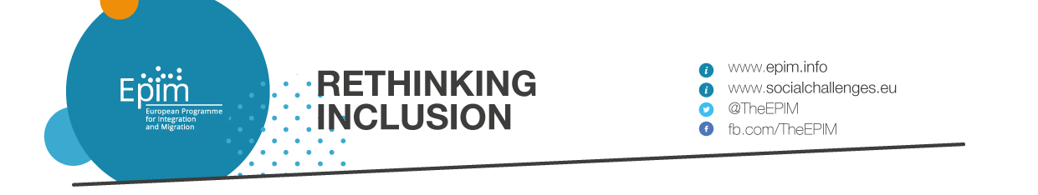
Application form - EPIM Call for Expressions of Interest

Rethinking Inclusion
Unlocking innovative solutions for migrant inclusion and social cohesion with a whole-of-society approach

- Applicant’s information

Name of the Applying entity
Address
Telephone number
Email address
Website
Contact person’s name & email
Legal representative’s name & email
Legal entity form
Organisation type: NGO, social enterprise, private company, diaspora organisation, migrant organisation, community-led organisation, academic and educational institution, others (please specify)
Provide a summary of your organisation’s mission (100 words maximum)
Applicant’s annual budget in 2017 and 2018 (EUR)
Referees: Please indicate contact details (name, position, email) for two referees

- Description of the solution

B.1. Your solution in brief

Title of the proposed solution
Please describe your solution in 240 characters
Is your solution already tested in real life? Yes - No
Please indicate the date since when your solution has been implemented
Location(s) of impact: please list places (i.e. country(ies), city(ies)) where your solution achieves most of its social impact
Target group(s): please list the beneficiaries targeted by the solution as well as an indicative number of the number of beneficiaries impacted so far.
Please indicate which of the following areas is addressed by your solution:
- Labour market and economic inclusion;
- Social empowerment;
- Literacy and language learning;
- Inter-cultural dialogue and cultural participation;
- Participation in (local) public life
Are you interested in adapting your solution and/or transferring your knowledge to stakeholders that address similar challenges? Yes - No

If so, please indicate in which country (or countries) you would be interested in transferring your knowledge/adapt your solution, among the following:
Belgium, Czech Republic, France, Italy, Portugal or Sweden

N.B: Please indicate “No preference” if you don’t have any preference.
Please upload a picture (with photo credits) that illustrates the solution

B.2. Your solution in details

- Problem definition: Please explain what problem(s) your solution is seeking to address and how that relates to the migrant inclusion challenge(s) described by EPIM.
(Max. 1700 characters, with spaces)

- Description and relevance of the solution: Please describe the proposed solution and explain how it contributes to one or several of the following drivers of inclusion: i.e. labour market and economic inclusion, social empowerment, literacy and language learning, inter-cultural dialogue and cultural participation or participation in (local) public life, in a sustainable way.
(Max. 2000 characters, with spaces)

- Adoption of a whole-of-society approach:
- Please explain to which extent the solution adopts a bottom-up approach, i.e. is developed and driven by local communities (including migrants)?
- Please explain to which extent the solution adopts an issue-focused approach and holds value for society as a whole?
(Max. 1700 characters, with spaces)

- Contribution to social cohesion: Please explain how the solution contributes to build bridges across diverse members of society, generates regular social interactions, direct encounters etc.?
(Max. 1700 characters, with spaces)

- Innovativeness of the solution: What makes your solution innovative (i.e. to which extent does it differ from other initiatives addressing the same issues, how does it contribute to new thinking in the area of migrant inclusion)?
(Max. 1500 characters, with spaces)

- Social impact:
- What has been the impact of the solution to date?
- How do you know such an impact has been achieved? When possible, please share with us a story, an article, a report illustrating such an impact.
(Max. 1700 characters, with spaces)

- Scalability:
- Does the solution have the potential to be adapted in other geographical contexts (i.e. the success of the solution is not context-specific)?
- Do you already know stakeholders who may be interested in adapting the solution in their own context? If so, which ones?
(Max. 1500 characters, with spaces)

- Organisational capacity:
- What is the current composition of the team required to design and implement the solution (e.g. number of staff, volunteers, types of roles etc.)? With EPIM’s support, would the team be able to support the social replication process through knowledge, expertise, experience and commitment?
- What is the budget required to implement the solution? How is it financially supported?
(Max. 1200 characters, with spaces)

- Additional information (optional)

- Please use this space to add any information you deem important for us to know regarding your organisation or the solution.

- Please feel free to share links and/or upload files that illustrate your solution or document its impact.

Please note that the content of this section will be made public for all eligible solutions, on the Social Challenges Platform. Content of the other sections will only be made available to the jury.

